EXP.NO: 8
Design and Development of an Online News Portal Using Servlet and JSP
AIM:
To design and develop an Online News Portal using Java Servlet, JSP, and MySQL database that allows users to view news articles and enables administrators to add, update, and manage news content dynamically.

ALGORITHM:
- Start the development process.
- Create a new Dynamic Web Project in Eclipse.
- Configure Apache Tomcat server and add the project to the server.
- Create the database in MySQL named "minitimes".
- Create required tables such as users and news.
- Insert sample news records into the news table.
- Create DBConnection.java class to establish database connectivity.
- Design index.jsp page to display news before login.
- Create signup.jsp and login.jsp pages for user authentication.
- Develop LoginServlet to validate user credentials.
- Create dashboard.jsp page to display news after login.
- Fetch news dynamically from database and display in grid layout.
- Add category navigation menu for filtering news.
- Implement search functionality using search.jsp.
- Add clickable news cards on dashboard page.
- Pass selected news ID to viewNews.jsp page.
- Develop viewNews.jsp to display complete news details.
- Add related news section using additional database query.
- Design professional UI using CSS styles.
- Test all modules including login, dashboard, search, and view.
- Fix errors and refine layout for better presentation.
- Stop the development process.

CODE:
Index.jsp:
<%@ page import="java.sql.*" %>
<%@ page import="com.minitimes.DBConnection" %>
<html>
<head>
<title>MiniTimes India</title>
<link rel="stylesheet" href="style.css">
</head>
<body>

<header>
<h1>MiniTimes India</h1>
<div>
<a href="login.jsp" class="btn">Login</a>
<a href="signup.jsp" class="btn">Signup</a>
</div>
</header>

<nav>
<a href="login.jsp">Politics</a>
<a href="login.jsp">Technology</a>
<a href="login.jsp">Sports</a>
<a href="login.jsp">Business</a>
<a href="login.jsp">Entertainment</a>
<a href="login.jsp">Health</a>
<a href="login.jsp">Education</a>
<a href="login.jsp">World</a>
</nav>

<h2 class="section-title">Latest News</h2>

<div class="container">

<%
Connection con = DBConnection.getConnection();
Statement st = con.createStatement();
ResultSet rs = st.executeQuery("SELECT * FROM news ORDER BY date DESC LIMIT 5");

while(rs.next()){

String content = rs.getString("content");
if(content.length() > 100){
content = content.substring(0,100) + "...";
}
%>

<div class="news-card">
<h3><%=rs.getString("title")%></h3>
<p class="meta">
<%=rs.getString("category")%> |
<%=rs.getString("date")%>
</p>
<p><%=content%></p>
<a href="login.jsp" class="read-more">Read More</a>
</div>

<%
}
%>
</div>
</body>
</html>
Style.css:
body{
font-family: Arial;
margin:0;
background:#f5f5f5;
}

header{
background:#d32f2f;
color:white;
padding:15px;
display:flex;
justify-content:space-between;
align-items:center;
}

.btn{
background:white;
color:#d32f2f;
padding:8px 15px;
text-decoration:none;
margin-left:10px;
border-radius:5px;
}

nav{
background:#333;
padding:10px;
text-align:center;
}

nav a{
color:white;
margin:0 15px;
text-decoration:none;
font-weight:bold;
}

.section-title{
margin-left:10%;
margin-top:20px;
}

.container{
width:80%;
margin:auto;
}

.news-card{
background:white;
padding:20px;
margin:20px 0;
border-radius:8px;
box-shadow:0px 0px 10px rgba(0,0,0,0.1);
}

.meta{
color:gray;
font-size:13px;
}

.read-more{
color:#d32f2f;
font-weight:bold;
text-decoration:none;
}
.login-container{
display:flex;
justify-content:center;
align-items:center;
height:80vh;
}

.login-form{
background:white;
padding:30px;
width:300px;
border-radius:8px;
box-shadow:0px 0px 10px rgba(0,0,0,0.1);
text-align:center;
}

.login-form input{
width:100%;
padding:10px;
margin:10px 0;
border:1px solid #ccc;
border-radius:5px;
}

.login-form button{
background:#d32f2f;
color:white;
border:none;
padding:10px;
width:100%;
border-radius:5px;
cursor:pointer;
}
}
Admin.jsp
<html>
<head>
<title>Admin Login</title>
</head>
<body>

<form action="AdminLoginServlet" method="post">
<h2>Admin Login</h2>
<input type="text" name="username" placeholder="Username"><br>
<input type="password" name="password" placeholder="Password"><br>
<button type="submit">Login</button>
</form>
</body>
</html>
News.jsp
<%@ page import="java.sql.*" %>

<%
String id = request.getParameter("id");

Connection con;
PreparedStatement ps;
ResultSet rs;

Class.forName("com.mysql.cj.jdbc.Driver");
con = DriverManager.getConnection(
"jdbc:mysql://localhost:3306/minitimes",
"root",
"root"
);

ps = con.prepareStatement("SELECT * FROM news WHERE id=?");
ps.setString(1,id);
rs = ps.executeQuery();
if(rs.next()){
%>
<h1><%=rs.getString("title")%></h1>
<p><b>Category:</b> <%=rs.getString("category")%></p>
<p><b>Author:</b> <%=rs.getString("author")%></p>
<hr>
<p><%=rs.getString("content")%></p>

<%
}
%>
LoginServlet.java
package com.minitimes;

import java.io.IOException;
import java.sql.*;

import jakarta.servlet.ServletException;
import jakarta.servlet.annotation.WebServlet;
import jakarta.servlet.http.*;

@WebServlet("/LoginServlet")
public class LoginServlet extends HttpServlet {

protected void doPost(HttpServletRequest request, HttpServletResponse response)
throws ServletException, IOException {

String email = request.getParameter("email");
String password = request.getParameter("password");

try {
Connection con = DBConnection.getConnection();

PreparedStatement ps = con.prepareStatement(
"select * from users where email=? and password=?");

ps.setString(1, email);
ps.setString(2, password);

ResultSet rs = ps.executeQuery();

if (rs.next()) {

HttpSession session = request.getSession();
session.setAttribute("user", email);

response.sendRedirect("dashboard.jsp");

} else {
response.sendRedirect("login.jsp?error=1");
}

} catch (Exception e) {
e.printStackTrace();
}
}
}
Addnews.java
package com.minitimes;
import java.io.IOException;
import java.sql.Connection;
import java.sql.PreparedStatement;
import jakarta.servlet.ServletException;
import jakarta.servlet.annotation.WebServlet;
import jakarta.servlet.http.*;
@WebServlet("/AddNewsServlet")
public class AddNewsServlet extends HttpServlet {
protected void doPost(HttpServletRequest req, HttpServletResponse res)
throws ServletException, IOException {

String title = req.getParameter("title");
String content = req.getParameter("content");
String category = req.getParameter("category");
String image = req.getParameter("image");

try {
Connection con = DBConnection.getConnection();

PreparedStatement ps = con.prepareStatement(
"insert into news(title,content,category,image) values(?,?,?,?)");

ps.setString(1, title);
ps.setString(2, content);
ps.setString(3, category);
ps.setString(4, image);
ps.executeUpdate();
res.sendRedirect("adminDashboard.jsp");
} catch (Exception e) {
e.printStackTrace();
}
}
}
DBconnection.java
package com.minitimes;
import java.sql.Connection;
import java.sql.DriverManager;
public class DBConnection {
public static Connection getConnection() {
Connection con = null;
try {
Class.forName("com.mysql.cj.jdbc.Driver");
String url = "jdbc:mysql://127.0.0.1:3306/minitimes";
String user = "root";
String pass = "root"; // put your password here
con = DriverManager.getConnection(url, user, pass);
System.out.println("Connected Successfully");
} catch (Exception e) {
e.printStackTrace();
}
return con;
}
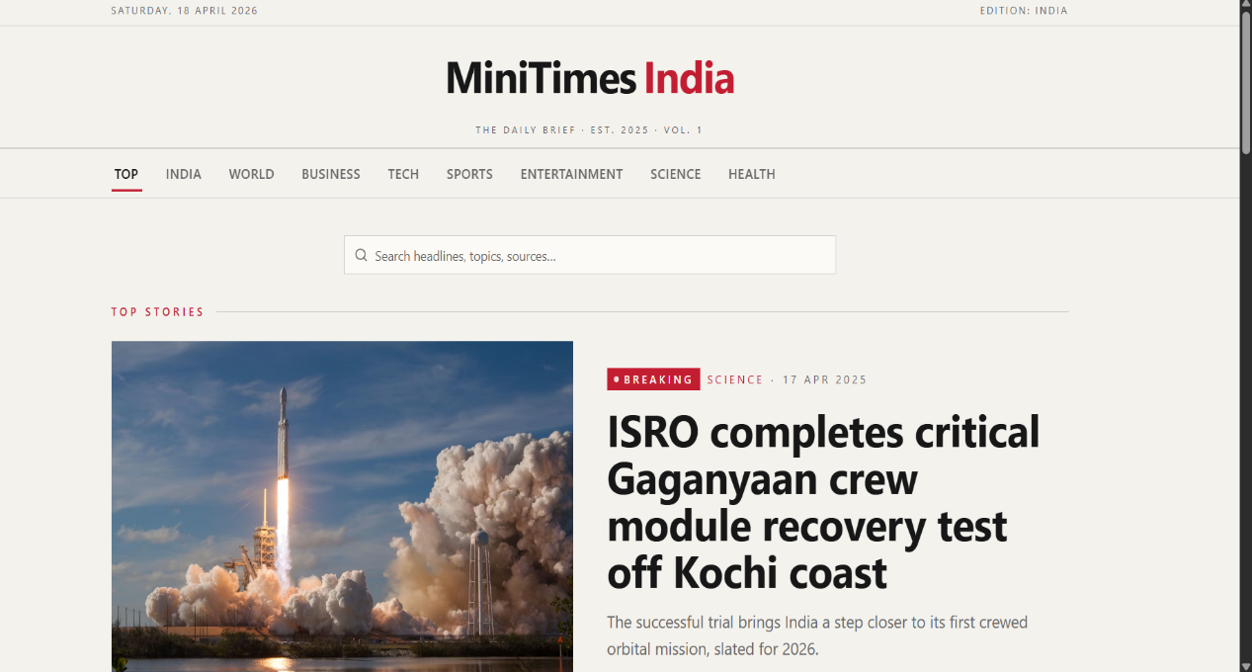
OUTPUT:
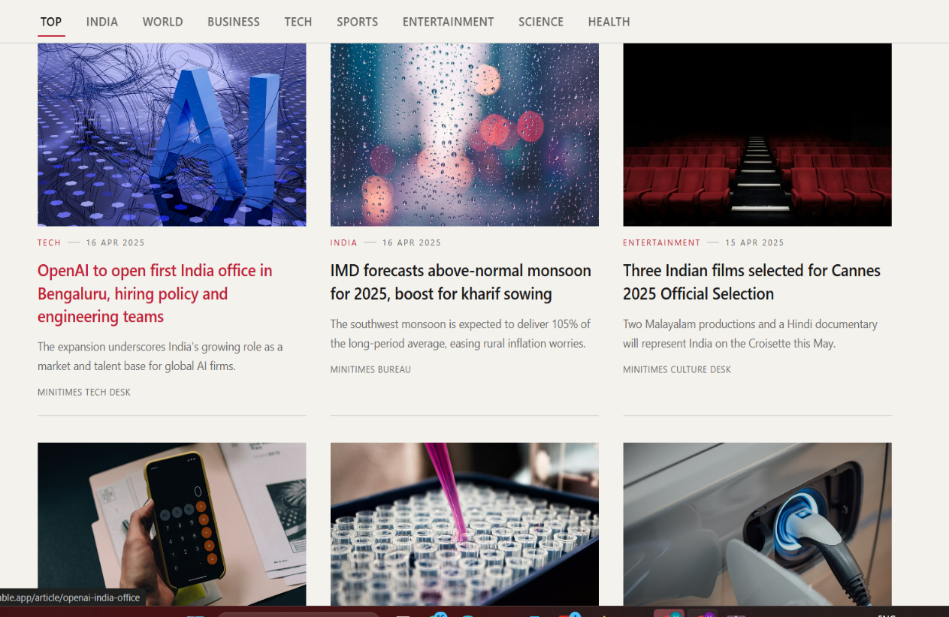

Result:
Html Page is created with embedded Bangalore map along with hot spot, frames ,map & Links.

